FUNCTIONAL AND PERFORMANCE PROCESS FLOW

“To visualize and streamline academic and administrative tasks, ensuring efficient, consistent, and automated service deliver

**USER**

* Streamlines tasks like student onboarding, IT ticket routing, or HR requests.

*Ensures consistent execution of academic and administrative processes.

*Speeds up services such as tech support, facility maintenance, and student services.

1. Creating Process Flow For Admission Table 2.All >> Process Flow>> New.

3.Fill the Details as given Below.right Click on toggle and click on the save .

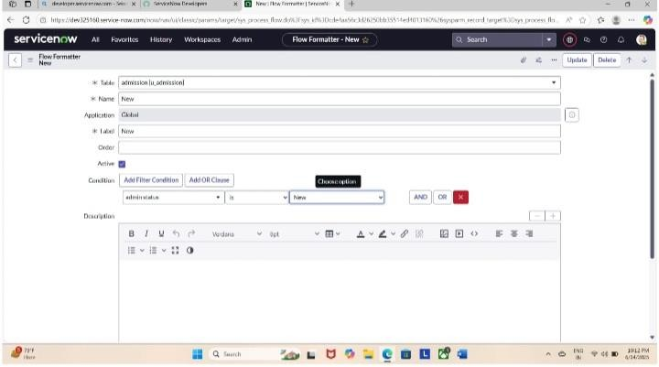

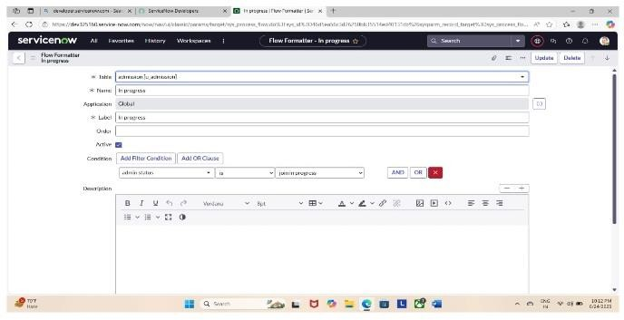

1. .Replace the Name and Label as below and click on Insert on stay.
2. .Replace the Name and Label in order and click on Insert on stay.
3. .Joined >> Rejected >> Rejoined >> Closed >> Cancelled.
4. .Order should be New >> IN Progress >> Joined >> Rejected >> Rejoined >> Closed >> Cancelled.